**Object Tracker & Follower Robot Using Raspberry Pi**

With advancement in robotic systems towards being autonomous surveillance robots the need for more smart thinking robots has become very essential. One of the aspect of tracking an object from its visuals has been taken up in this project Object Tracker and Follower Robot. In essence this project clubs in image processing and driving a robot autonomously with what visuals have been caught as has been in the case of Machine Vision projects. This project will be using a Raspberry Pi processor board for computational purpose and driving of the robot. The camera attached to the system captures the images of the front of the robot where it is attached. By monitoring a stream of incoming images the robot is able to autonomously decide to proceed in which direction it should go. The incoming visuals are processed using image processing techniques.

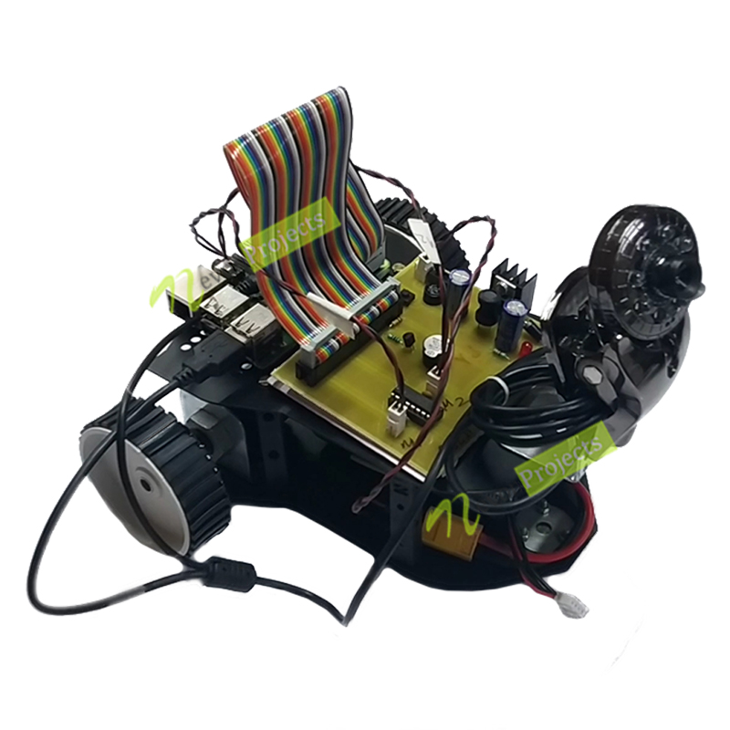

* **Hardware Specifications**

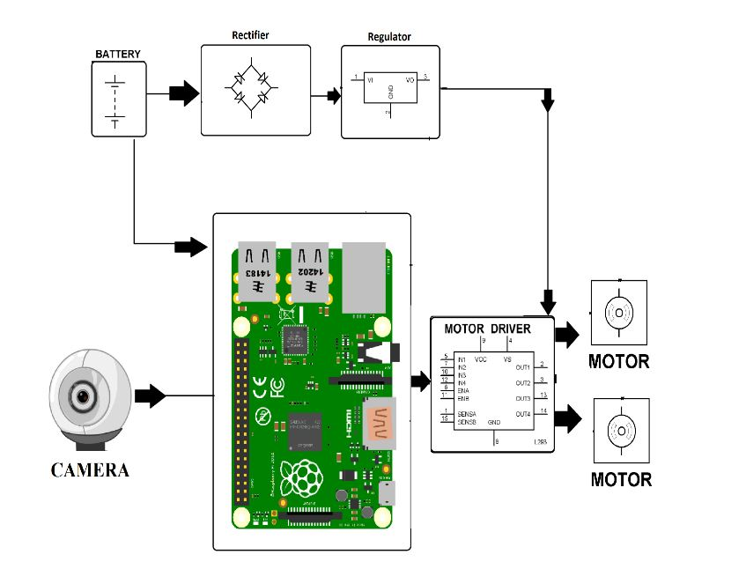

**Link:**

<https://nevonprojects.com/object-tracker-follower-robot-using-raspberry-pi/>

**Blutooth Module For Respberry pi**

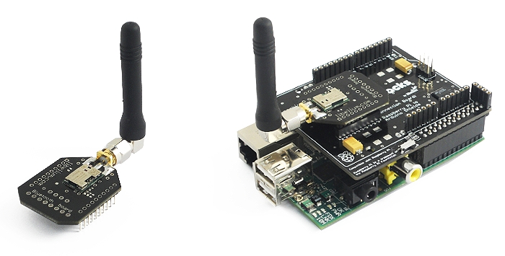

The Bluetooth module can be connected directly in the Raspberry Pi to Arduino shield.

For the device discovery example we are going to access the Bluetooth module through a graphical serial port communications program.

Service discovering is a tool that we can use to discover services in a Bluetooth device.

In this basic example we'll use a Raspberry Pi with Bluetooth module and a PC with a Bluetooth USB dongle (Linksys Bluetooth Adapter).

His example is very similar to the previous one, with the difference that now we use the PIN security for the connection between Raspberry Pi with Bluetooth module and PC.

**Link**

<https://www.cooking-hacks.com/documentation/tutorials/raspberry-pi-bluetooth>